SNAKES AND LADDERS PHYSICAL CHALLENGE
Key Stage 1 and 2
***** KS2 must start on medium challenge or above******

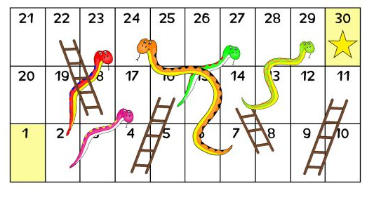

SPEED BOUNCE
2 FOOTED JUMPS OVER A LINE - eg DRAW A LINE WITH CHALK OUTSIDE ( BE CAREFUL IF USING OUTSIDE SURFACE)
STEP UPS
USE THE STAIRS AND REMEMBER TO STEP ONTO WHOLE FOOT NOT JUST YOUR TOES
RULES:
- ONLY USE 1 DICE
- PLAY INDIVIDUALLY PERSONAL CHALLENGE OR WITH AS MANY PEOPLE AS YOU LIKE
- CAN BE DONE INSIDE OR OUTSIDE
- WARM UP BEFORE STARTING CHALLENGE
- SAFETY FIRST WHEN DOING CHALLENGES
- MODIFY CHALLENGE WHERE APPROPRIATE
NUMBER  CHALLENGE | EASY CHALLENGE | MEDIUM CHALLENGE | HARD CHALLLENGE | SUPERSTAR CHALLENGE
1 – GET STARTED
2 – Tuck Jumps | 10 secs | 25 sec | 45 secs | 1 min
3 – Push Ups | 10 | 20 | 30 | 50+
4 – Star Jumps | 15 | 30 | 40 | 40+
5 – Step ups | 10 | 25 | 35 | 45+
6 – Partner selects the challenge
7 – Balance on one leg | 10 secs | 15 secs | 35 secs | 45+ secs
8 – Exercise of your choice
9 – Speed Bounce | 15 | 25 | 35 | 45+
10 – Cycle legs | 20 | 35 | 45 | 50+
11 – Sit ups | 10 | 15 | 25 | 30+
12 – Jogging on the spot | 10 | 15 | 30 | 35+
13 – Draw circles with your arms | 10 secs | 20 secs | 30 secs | 40+ sec
14 – Partner chooses exercise
15 – Bunny hops | 15 secs | 25 sec | 35 secs | 45+ secs
16 – You choose your exercise
17 – Step Ups | 10 | 25 | 35 | 45+
18 – Tuck Jumps | 10 secs | 25 secs | 45 secs | 1 min
19 – Star jumps | 15 | 30 | 40 | 40+
20 – Bunny Hops | 15 secs | 25 secs | 35 secs | 45+ secs
21 – Jogging on the spot | 10 | 15 | 30 | 35+
22 – Sit Ups | 10 | 15 | 25 | 30+
23 – Squats | 10 | 20 | 30 | 35+
24 – Partner chooses exercise
25 – Draw circle with arms | 15 secs | 25 secs | 35 secs | 45+ secs
26 – Speed Bounce | 15 | 25 | 35 | 45+
27 – Cycle legs | 20 | 35 | 45 | 50+
28 – Push Ups | 10 | 20 | 30 | 40+
29 – You choose your exercise
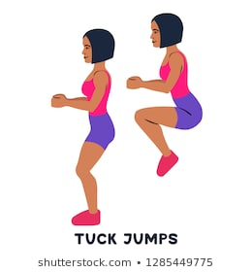
Cycle Legs
Push Ups
EASY MEDIUM/HARD CHALLENGE
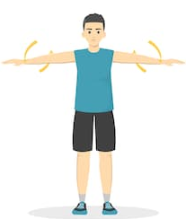
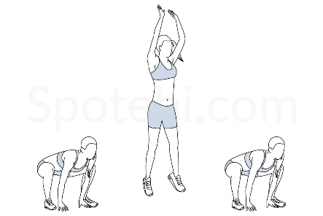
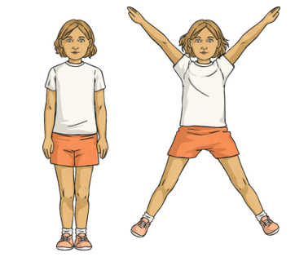
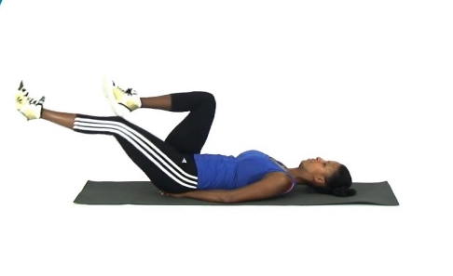
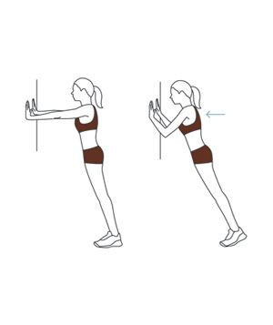
Circle arms
BUNNY HOPS

Squats
Star jumps
Balance
SIT UPS
1. EASY 2. MEDIUM 3. HARD / SUPERSTAR

